Mental Health Resources & Support
Local, Free NHS Resources and Support
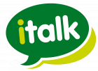 | italk – self-referral for psychology & ‘talking therapies’. You don’t need to see a doctor to get referred. Contact them by phone or online.  There are also helpful resources on the website. |  www.italk.org.uk   023 8038 3920   info@italk.org.uk
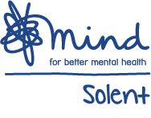  For Fareham &  Gosport | Mind Wellbeing Centres are very friendly and welcoming places with an informal atmosphere. Activities are designed to help individuals towards recovery. We also offer private and confidential emotional support, and one-to-one help to raise aspirations, goals and ambitions.  Information pack  Self-referral form | Fareham Wellbeing Centre  126 West Street  Fareham, PO16 0EP   01329 281445   adminfg@solentmind.org.uk  https://www.solentmind.org.uk/ourservices/wellbeing-services/
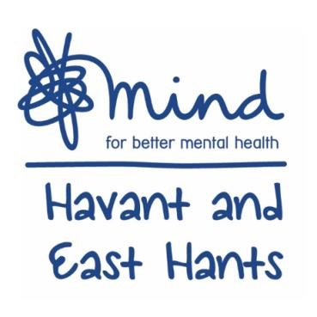 | This can be accessed by self-referral and professional referrals, for people that would like support for their mental health and wellbeing.  After referral, you will be booked in for an assessment where we will talk through what you would like to achieve and how they may be done. At the end, a recovery plan will be compiled together with the support from the adults service though our courses, workshops and peer support groups. Self-referral form | The Hub  Havant & East Hants Mind  39 Park Parade,  Leigh Park,  PO9 5AA   https://www.easthantsmind.org/wellbeingservices/adults-wellbeing/   02392 498916   wellbeing@easthantsmind.org
Adult Safehaven | The Adults’ Safe Haven is for any adult needing immediate support at a time of crisis. You can be referred by a professional; like your GP or NHS 111 or you can self refer by attending the Safe Haven location. 6pm to 10pm 365 days a year | Havant and East Hants Mind Adults’ Safe  Haven, The Hub, Leigh Park, Dunsbury Way,  Havant, PO9 5EW   0300 303 1560
  SilverCloud | Psychology: SilverCloud is supported by italk, and is particularly suitable for people who feel it may be hard to go to appointments or speak on the telephone. It is a self-referral for online-based psychological therapies. |  https://italk.silvercloudhealth.com/signup/

In times of crisis – all of the following are here to help you
Contact the Safehaven | Safe Haven, The Hub, Leigh Park, Dunsbury Way, Havant, PO9 5EW; 0300 303 1560; 1800-2200 365 days
Contact the Samaritans | You do not have to be suicidal. Call 116 123. jo@samaritans.org (24h response time)
Call 111 | There is a mental health practitioner to help you, 24/7
Call your GP | Between 0800-1800
Call your team | If you are under the community mental health team, call the number they gave you. There’s a crisis number on their answer phone if it’s out of hours.
SHOUT Text Line | Text SHOUT to 85258 – available 24/7
Visit ‘Staying Safe’ | https://stayingsafe.net/ by people who have got through similar experiences. Make a safety plan.
distrACT |   The distrACT app gives you easy, quick and discreet access to information and advice about selfharm and suicidal thoughts.

Self-Help Resources and Reliable Information Sources
Samaritans Self-Help | Use our self-help web-app to track your mood and find practical tips and techniques to look after your emotional health.
Self-Help Guides | NHS-produced self-help guides on a variety of mental health subjects
Every Mind Matters | Guidance on mental health and wellbeing, including creation of an individualised plan
Living life to the full | Free online courses covering low mood, stress and resiliency. Work out why you feel as you do, how to tackle problems, build confidence, get going again, feel happier, stay calm, tackle upsetting thinking and more
Staying Safe | Particularly useful if you suffer from thoughts of self-harm or suicide. You can create a free safety plan.
Mood Juice | A collection of resources on a wide range of mental health and lifestyle issues
MyCompass | A personalised self-help tool for your mental health
BeyondBlue | information and support to help achieve best possible mental health
Get Self Help | This website provides CBT self-help and therapy resources, including worksheets and information sheets and self help mp3s
Sleep Resources | Sleepstation This link will take you through a questionnaire and then the options for access will appear. Just select 'Request NHS access' for FREE access.  The Sleep Council  Sleep and arthritis
Reliable Sources of Information | https://patient.info www.nhs.uk  Royal College of Psychiatrists information  Rethink Mental Illness  Time to Change

Specific Areas of Need – the following organisations offer help and support
Drug/Alcohol Problems | Inclusion Hampshire https://www.inclusion.org/inclusion-recovery-hampshire/  Frank https://www.talktofrank.com/get-help/find-support-near-you  DrinkAware https://www.drinkaware.co.uk/  Action on Addiction https://www.actiononaddiction.org.uk/  AdFam https://adfam.org.uk/help-for-families/useful-organisations
LGBT+ | Switchboard is a confidential LGBT+ helpline: phone, webchat and email. https://switchboard.lgbt/
Older People & Dementia | Age UK. Advice line: 0800 678 1602 Befriending: https://www.ageuk.org.uk/services/  Alzheimer’s UK support: 0333 150 3456 https://www.alzheimers.org.uk/  Princess Royal Trust for Carers: https://carercentre.com/ Care Support Workers: 01264 835246 Emergency  Dementia UK: https://www.dementiauk.org/get-support/ Helpline: 0800 888 6678
Anxiety Conditions | Anxiety UK: https://www.anxietyuk.org.uk/ OCD Action: http://www.ocdaction.org.uk/
Neurological Conditions | The Brain Charity offers emotional support, practical help and social activities to anyone with a neurological  condition and to their family, friends and carers. https://www.thebraincharity.org.uk/  National Autistic Society: https://www.autism.org.uk/ 0808 800 4104  Autism Hampshire: https://www.autismhampshire.org.uk/ 02380 766162  ADHD Foundation: https://www.adhdfoundation.org.uk/  ADDISS: ADD Information and Support Service: http://www.addiss.co.uk/ 020 8952 2800
Bereavement | Cruse Bereavement Care: https://www.cruse.org.uk/ Helpline: 0808 808 1677
Trauma | Combat Stress: https://www.combatstress.org.uk/ Helpline: 0800 138 1619  PTSD: https://www.ptsduk.org/  Victim Support (victims and witnesses of crime/accidents): https://www.victimsupport.org.uk/
Eating Disorders | Beat: https://www.beateatingdisorders.org.uk/ Helpline: 0808 801 0677 and webchat.
Depression | Depression UK: http://depressionuk.org/  Side by Side: https://sidebyside.mind.org.uk/ - an online forum run by the charity Mind  CALM (Campaign Against Living Miserably): https://www.thecalmzone.net/ 0800 58 58 58
Abuse | A list of local and national organisations to support victims of abuse is on the Hampshire Constabulary website
Relationship Difficulties | Relate: https://www.relate.org.uk/ Tel: 0300 0030396

Support for Parents
PANDAS  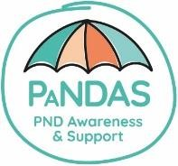  Charity for perinatal mental illness offers free telephone support MonSun 9am-8pm on 0808  1961 776 or by email on info@pandasfoundation.org.uk (response within 72 hours) https://pandasfoundation.org.uk/ | Channel Mum    Support – including for mental health - in an online community.  www.channelmum.com/c/mental-  health | DadPad  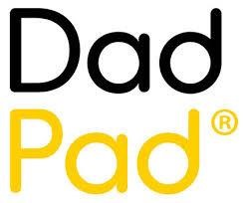  This is support for fathers, produced alongside the NHS. 07403 274 757 https://thedadpad.co.uk/  hello@thedadpad.co.uk
  The Hampshire Healthy Families information on all things health and families in Hampshire.  www.hampshirehealthyfamilies.org.uk | Wessex Healthier Together  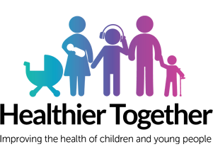  The website provide advice for parents, young people and pregnant women,  https://what0-18.nhs.uk/ | 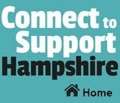  Connect to Support Hampshire This website provides you with resources to look after yourself, stay safe and connected with your local community.  www.connecttosupporthampshire.org.uk
Hampshire Lanterns A support group run by Mums with personal experience of mental health problems during pregnancy or after childbirth.  https://hampshirelanterns.com/ | 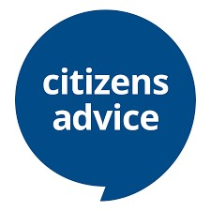  Citizen’s Advice This charity gives information on family, housing, health, benefits, work, money and more.  https://www.citizensadvice.org.uk/ | Home Start  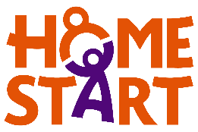  Home Start volunteers work alongside families to offer parental  support with the stresses of life, when things are tough.  www.home-start.org.uk/

Support for Children & Young People
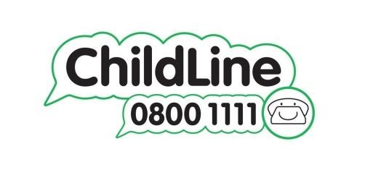 |  |  | 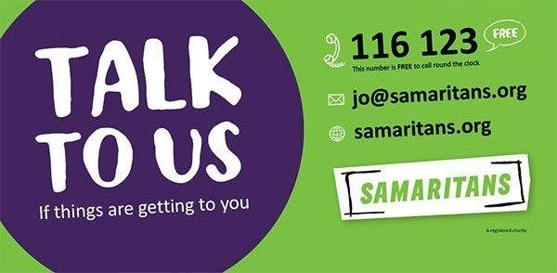 |  |  | 
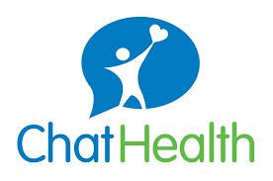  School Nurses are able to offer you confidential advice and support should you need it. The ChatHealth text service is an easy way for young people 11-19 to confidentially ask for help with a range of issues. ChatHealth allows young people in Hampshire to text messages to a dedicated number.  07507 332160  Once received, the school nurse will respond to the text within one working day.  ChatHealth is available Monday to Friday from 9am-4.30pm |  |  |  |  |  |   For under-25s – a variety of health concerns, including mental health.  https://www.themix.org.uk/   0808 808 4994  Also includes 1-to-1 chat (4pm-11pm)   Crisis Messenger: text THEMIX to 85258, plus  email – see contact details   https://www.themix.org.uk/get-support/speak-toour-team
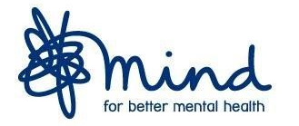  Information and support for young people |  | KOOTH  At Kooth, we believe every young person has the right to thrive and to access high quality mental health care. Kooth.com is commissioned by the NHS, Local Authorities, charities and businesses to provide anonymous and personalised mental health support for Children and Young People. With over 4000 logins per day, we provide end to end support whatever the need.    https://www.koothplc.com/our-products/young-people  https://www.koothplc.com/our-products/young-people |  |  |  | 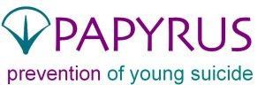  0800 068 4141  pat@papyrus-uk.org
Children’s  Crisis Lines | 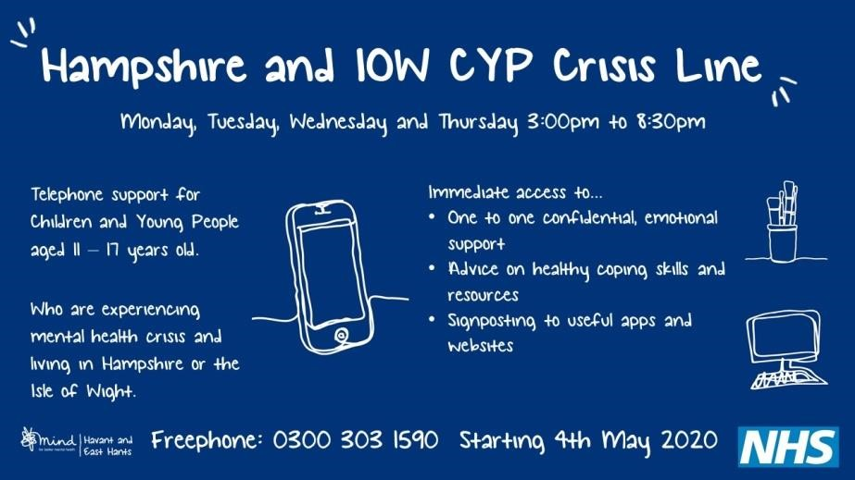 |  |  |  | Freephone Crisis Line for 11-17 year olds. The crisis line provides immediate access to safe and confidential support for young people experiencing difficulty with their mental health.  Monday, Tuesday, Wednesday & Thursday 3pm – 8:30pm.   Freephone: 0300 303 1590.
Child & Young  Person’s  Safehaven | The Young Person’s Safe Haven is an out of hours crisis support service for any young person in the Havant Borough aged 11-17 years old. It provides a safe & confidential space for young people experiencing difficulty with their mental health or wellbeing to access immediate emotional support, and take part in activities such as games, mindfulness, art & crafts and peer support. |  |  |  | Tuesday, Wednesday and Thursday evenings 5pm – 8pm. No referral or appointment  needed (recommended 5-7pm for 11-13yr olds)   During COVID: Freephone 0300 303 1580  Pallant House Play Café, The Pallant, Havant, PO9 1BE
Think Ninja |  |  |  | Mee Too | Blue Ice
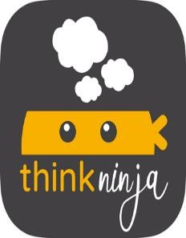  This is an App for 1018 year olds to learn about mental health & develop skills to build resilience. |  |  |  | 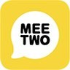  A safe and secure  forum for teenagers wanting to discuss any issue affecting their  lives. | 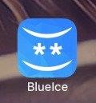  This app helps young people manage emotions and reduce the urge to self-harm.

Apps (Free)
 |  |  | 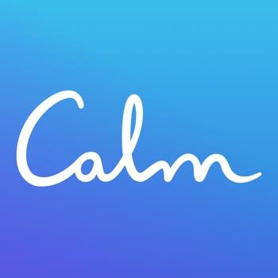 | 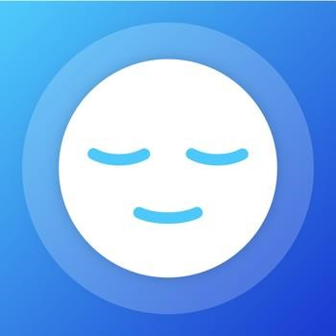
Insight Timer | Headspace | Calm Harm | Calm | Mindshift
Help with sleep, anxiety and stress. | Learn mindfulness and meditation – manage  stress, anxiety, sleep and depression. | Help when struggling with urges to self-harm | Stories for mediation and sleep | CBT-based app to manage anxiety

