What will happen next?

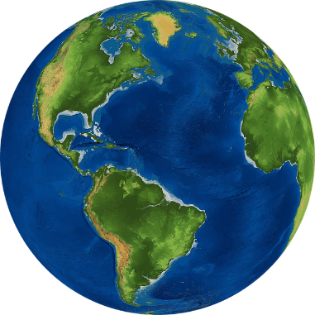
The Coronavirus has affected the whole world

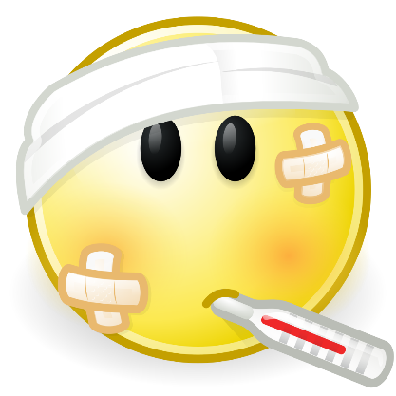
The Coronavirus is a virus that has made people feel unwell

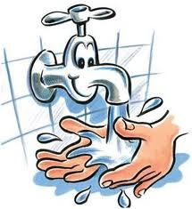
I have helped stop the spread of the virus by washing my hands and keeping away from people

I have also helped stop the spread by staying at home and doing my schoolwork there



I have not been able to go to my favourite places

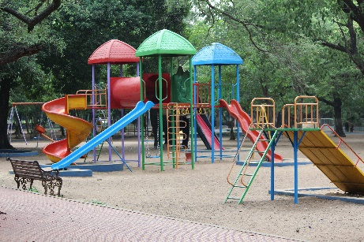

Having time off school is a change to my routine and this can be tricky
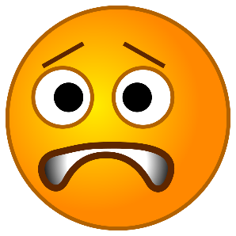

Once the Coronavirus has gone, I will be able to go to my favourite places again


My Parents and carers will let me know when I can go back to school

I might find it hard going back to school because I have had time at home. Everything will be OK, but if I feel worried, I can talk to an adult about it


